Board Meeting

December 12, 2023

Wakulla County Public Library

10:30 AM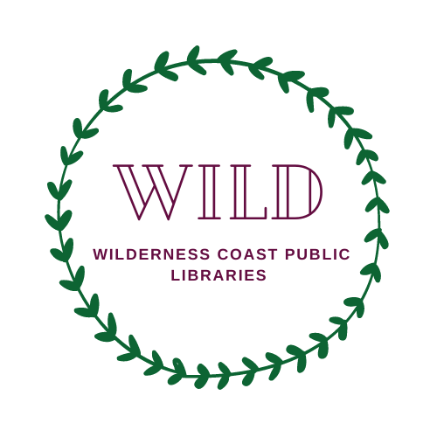

WILD

Agenda 12/12/23



Wilderness Coast Public Libraries

Serving Franklin, Jefferson, and Wakulla Counties

WILD Governing Board Meeting

Tuesday, December 12th, 2023

**Agenda**

● Changes to Agenda

● Introductions

**OLD BUSINESS:**

● Minutes from the September meeting - vote

● Financial Report with WILD Accountant Keith Dean - vote

● Administrator Report

**NEW BUSINESS:**

* Summary list of Administrator Accomplishments
* Annual Review of Central Administrator
* 3% raise for WILD office staff

**OTHER BUSINESS:**

Franklin, Jefferson, and Wakulla Director Reports